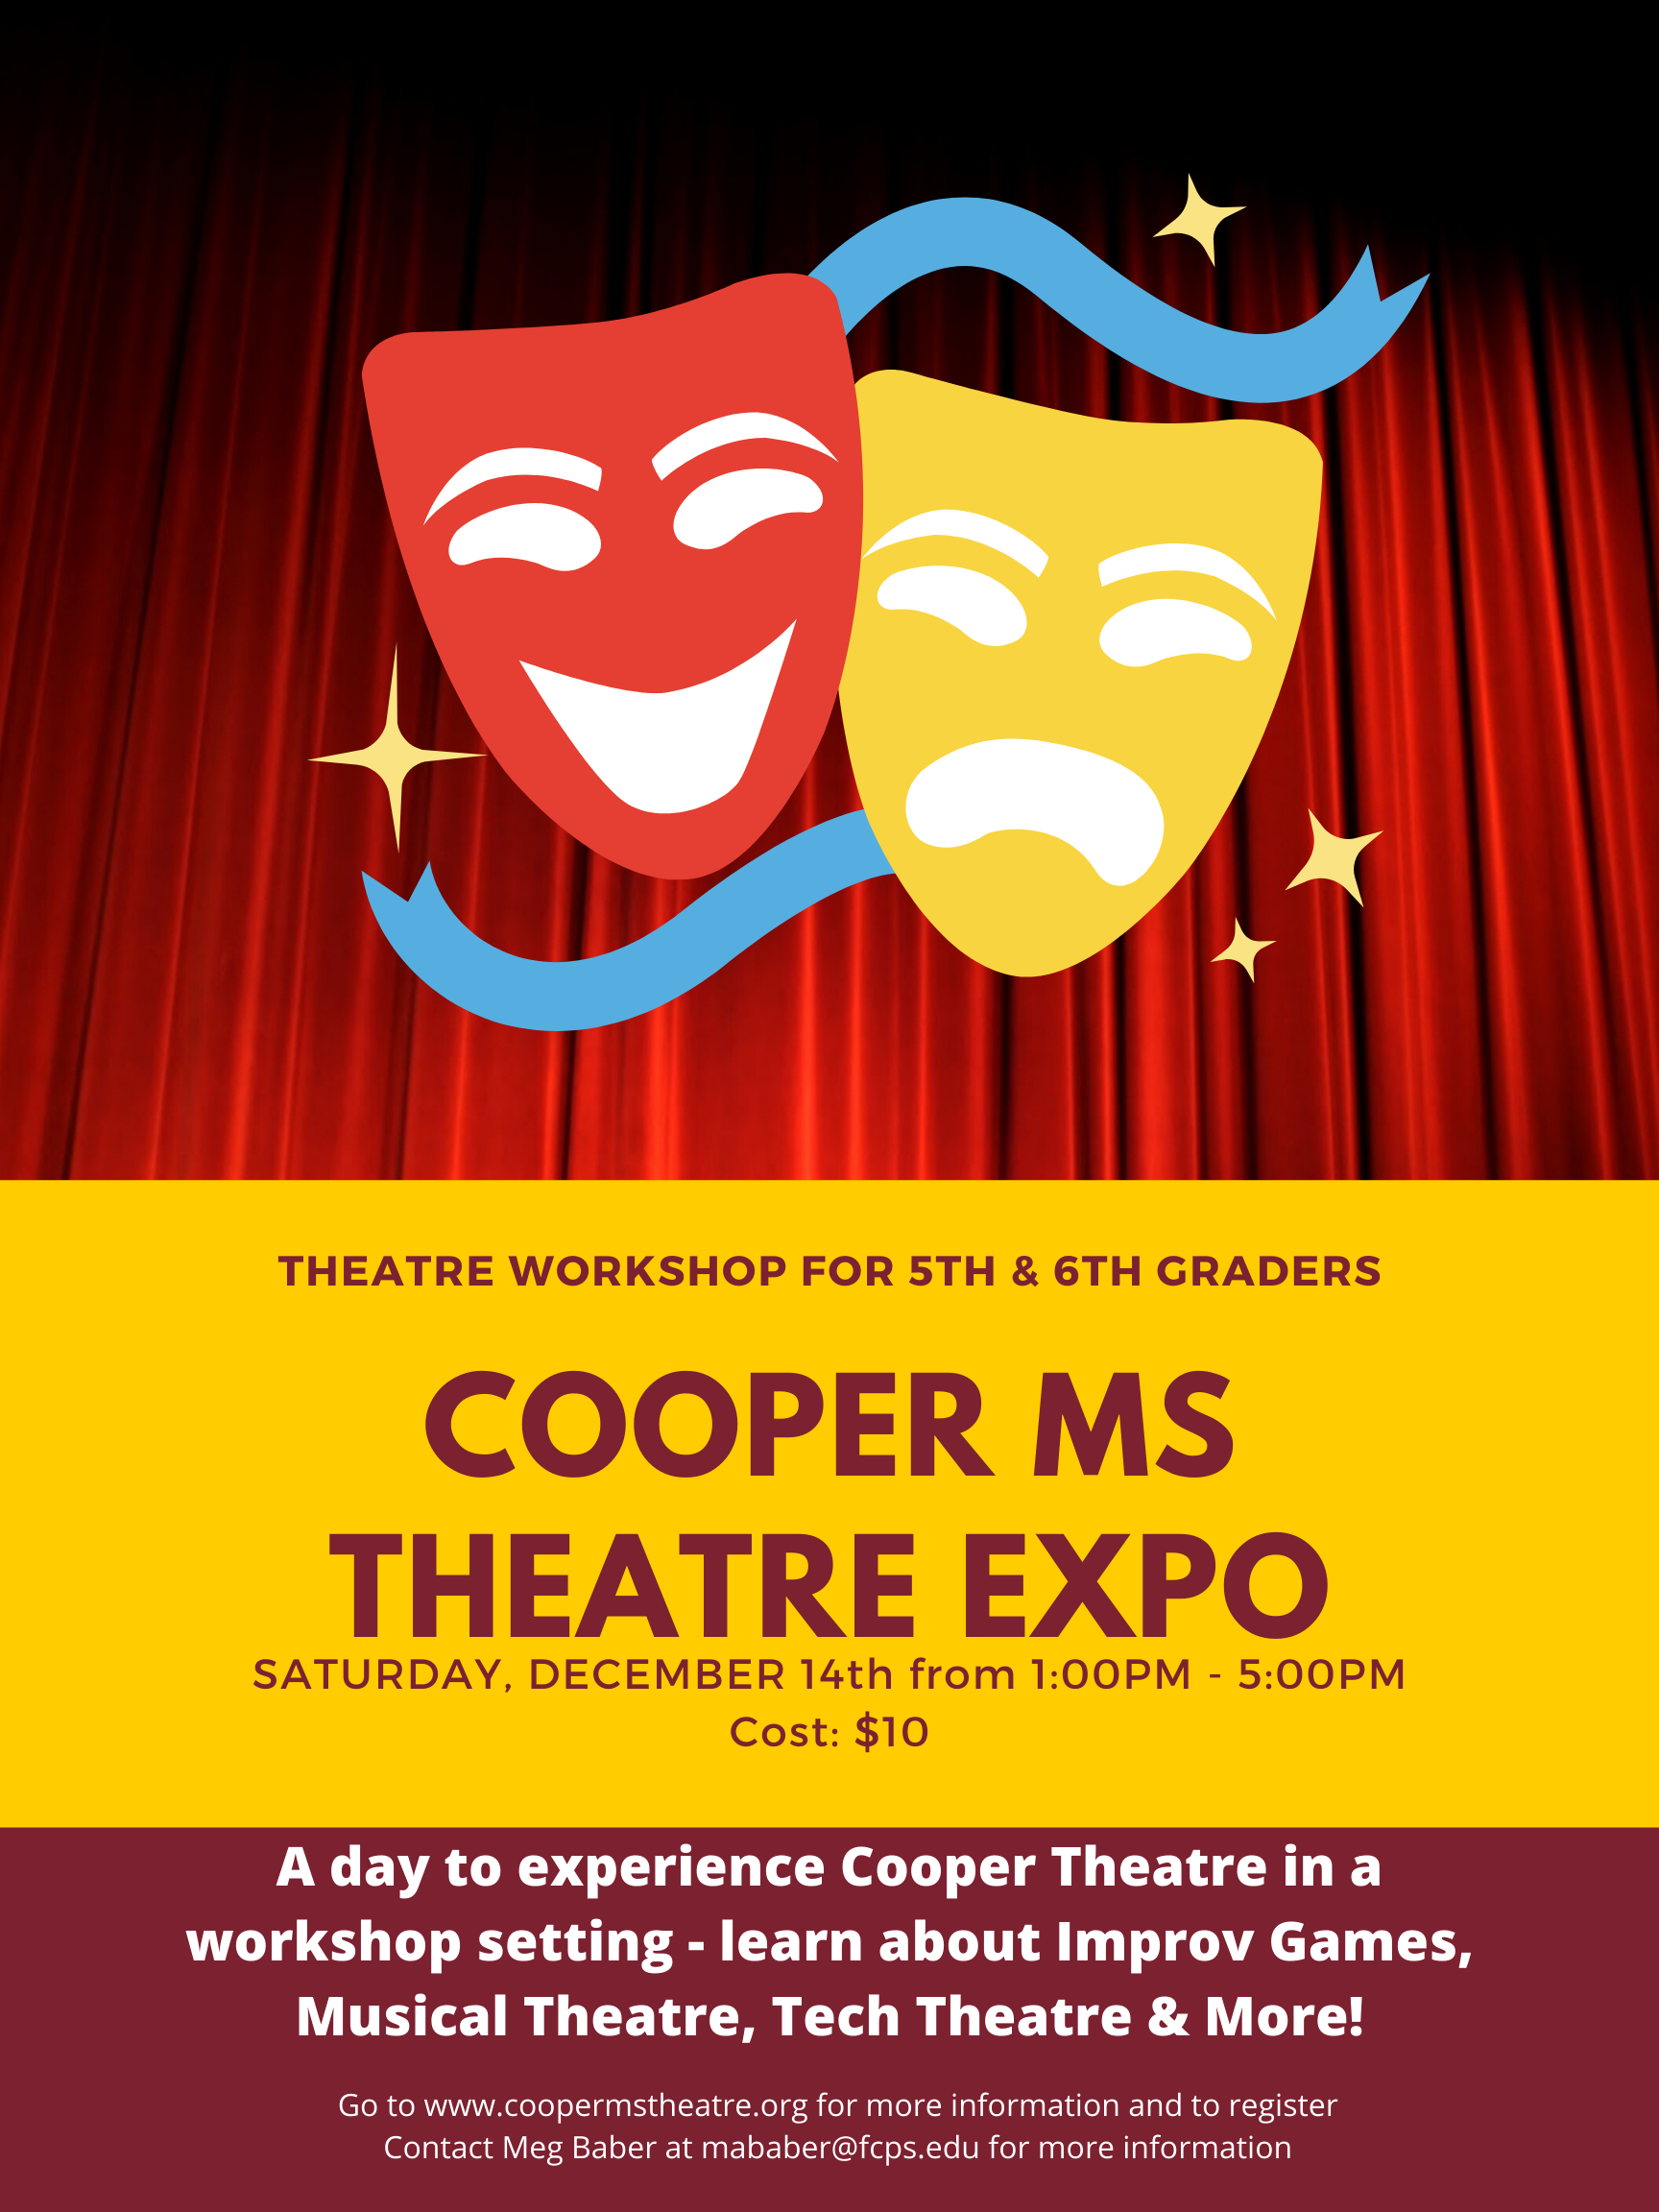
COOPER THEATRE EXPO 2019

Dear Elementary School 5th & 6th Grade Students,

You are cordially invited to the Theatre Expo at Cooper Middle School on Saturday, December 14th, from 1:00 to 5:00 p.m. The Theatre Expo is a fun-filled day of workshops so that you can experience what middle school theatre is like and to learn from theatre professionals and work with middle school theatre students!

The cost of the event is $10 per student. This price includes three workshops and pizza. Students are responsible for their own transportation to and from Cooper Middle School.

If you are interested, please register online and complete payment via Myschoolbucks no later than November 29th. There are a limited number of spaces for this workshop, so it’s first paid, first served! Online registration and the $10 registration fee are due to Cooper Middle School no later than November 29th. If you are paying by check, it should be made out to Cooper Middle School. Please note that the workshop registration fee is NONREFUNDABLE once paid.

Each class will be one hour long with five minutes of passing time between workshops. Students will be given a rotation schedule for the workshops when they arrive at Cooper for the expo. There will be a break with pizza for all between the second and third workshop. Students will also have an opportunity to interact with Cooper Middle School theatre and choir students to learn about the programs available at Cooper.

We look forward to seeing you at the Expo!

Sincerely,
Meg Baber
Cooper Middle School
Theatre Arts Teacher
mababer@fcps.edu

Scan to access online registration form or go to:
https://docs.google.com/forms/d/10SOrB_G4dpN-D5obAiex3JcZOBw3_eVsNoBWBayK8wc/viewform?edit_requested=true

FALL THEATRE EXPO 2019
WORKSHOP DESCRIPTIONS
Saturday, December 14th at Cooper Middle School

Special Effects Make-up – Learn and practice different make-up procedures such as creating realistic bruises and gory cuts. Taught by Laura Macario.
Laura Macario began her career teaching drama and music in 1984 (in FL, NC, CA and VA). She directed 2 – 4 main stage musical shows per year from 1984 until 1996 and also worked with community theatre in makeup, music, and directing main stage shows. She left the teaching world in 1996 to work at MTS Productions and spent two years immersed in technical theatre and new technology. In 1998 she purchased MTS Productions and turned it into what is now Artistic Concepts Group, Inc.– a complete production service with a heart for theatre education; a love of theatre; equipment and supplies for the entertainment and special event markets as well as design, sales, and installation of all the equipment that it takes to accomplish live events anywhere.

Improv – Develop your improvisational skills and have fun learning theatre games and exercises. Taught by Pete Bergen.
Pete Bergen is a DC based actor, comedian and improviser. He has trained at the Upright Citizens Brigade Theater in New York and was accepted to their advanced study program. He also completed the curriculum at Washington Improv Theater and has been a faculty member there for ten years. Pete has brought his high energy workshops to dozens of schools in Fairfax County and likes nothing more than to see people come together and learn this wonderful universal language of improv and theater.

Musical Theatre - Musical theatre actors must sing, dance AND act… at the same time! Put it all together as you learn a musical theatre number from our upcoming Cooper musical, Rock of Ages. Taught by Meg Baber & Chelsea Kohl.
Meg Baber has been teaching theatre at Cooper Middle School for 16 years. She studied musical theatre at James Madison University. Many of her former students are now pursuing a career in theatre, in DC, New York, Chicago and other places around the country.
Chelsea Kohl

Schedule for the day:

1:00 – 1:10: Meet and greet in the cafeteria
1:10 – 2:10: Workshop 1
2:15 – 3:15: Workshop 2
3:15 – 3:45: Pizza break, meet with Cooper students
3:45-4:45: Workshop 3
4:45 – 5:00: Closing in the cafeteria

Teachers may photograph and videotape students as they participate in workshops for professional sharing. Members of Cooper’s publicity team may also be interviewing students and recording portions of classes to make promotional videos for FCPS Theatre and this educational event. The videos and photographs may be posted to various FCPS websites, social accounts, and YouTube channels. Teachers will adhere to best practices when sharing images from the workshop, following a conservative policy regarding privacy settings, and avoiding identification of students by their full names. If you have submitted an opt-out form to your school on behalf of your child, please inform the Cooper theatre teacher prior to the workshop date.

